­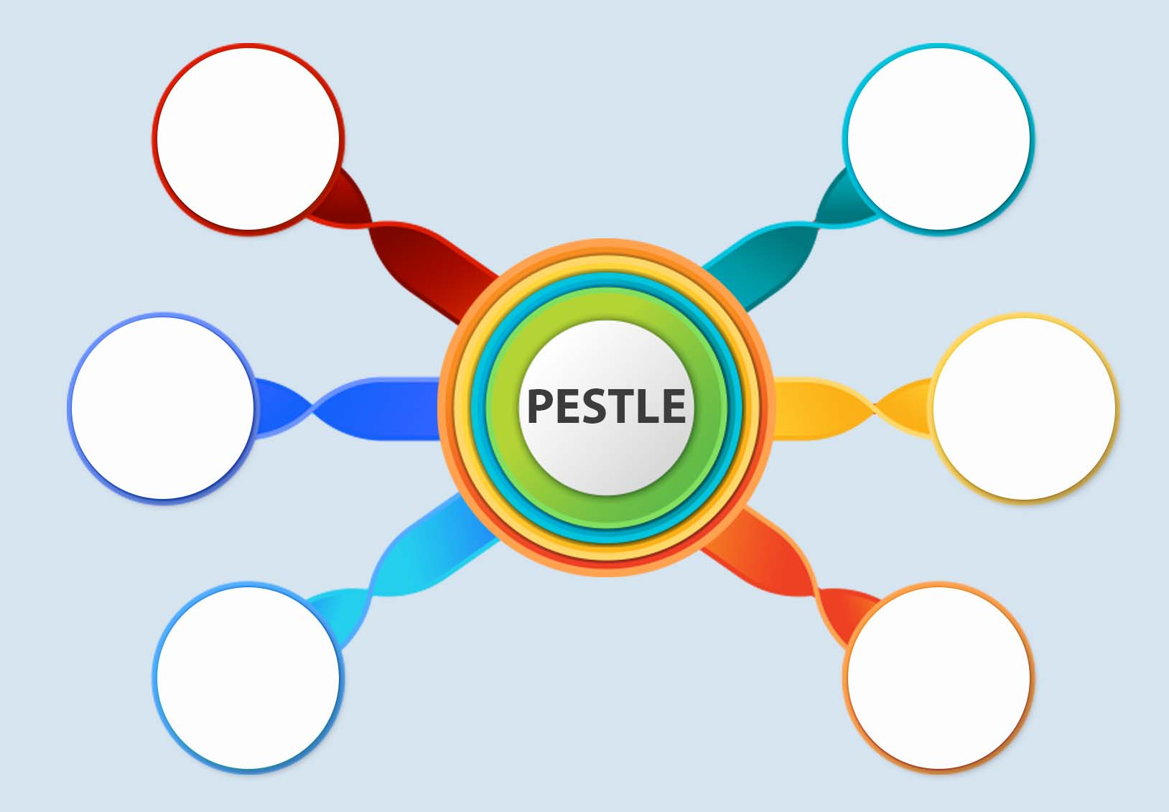

**Economic**

Weather climate

Climate

Population

Growth rate

Distribution

Economic

Growth

Exchange

**Technology**

Discrimination

Antitrust

**Legal**

**Environment**

**Social**

Technology

Incentives

Level

Government

Political

Stability

**Political**