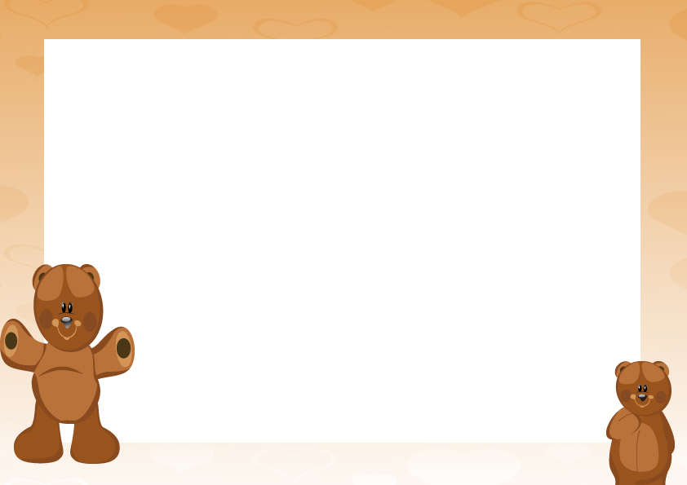

BUILD BEAR CERTIFICATE

Presented to
____________________________________

For

_____________________________________

Date:__________________

Signed:_________________

