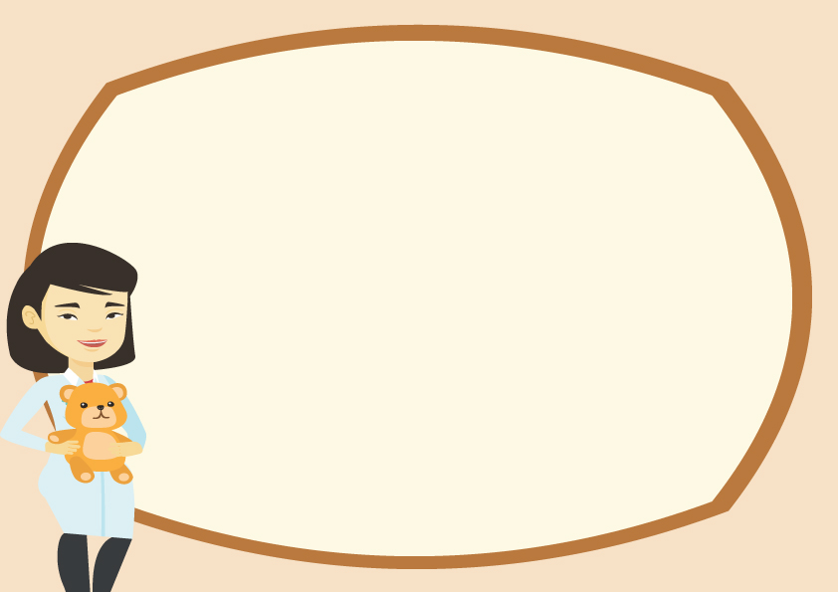

BIRTH CERTIFICATE

Teddy Bear’s Name : _______________________________________

Belongs To :______________________________________________

Place Of Birth :___________________________________________

Birth Date:_______________________________________________

Workshop Name:____________________________________________

Date:______________ Signed:_________________

