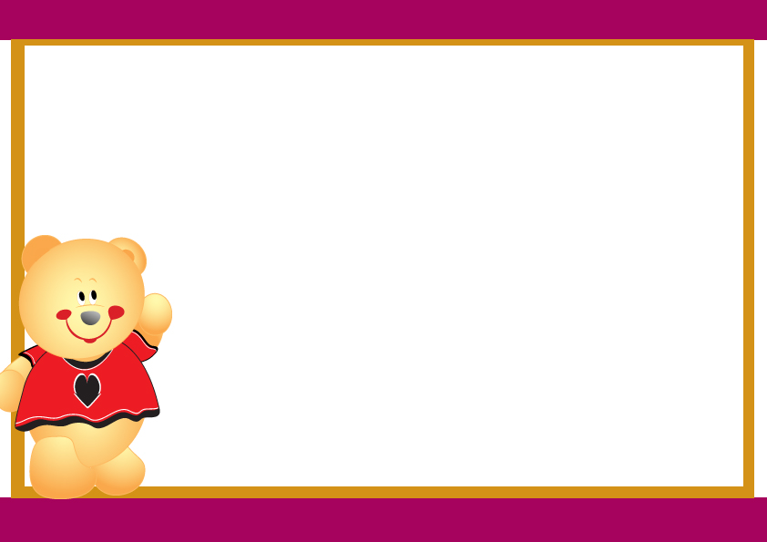

BUILD BEAR CERTIFICATE

This certifies that on_________________

For
_________________________________________

______________________________________

Name Given To Bear:__________________

Signed:_________________

