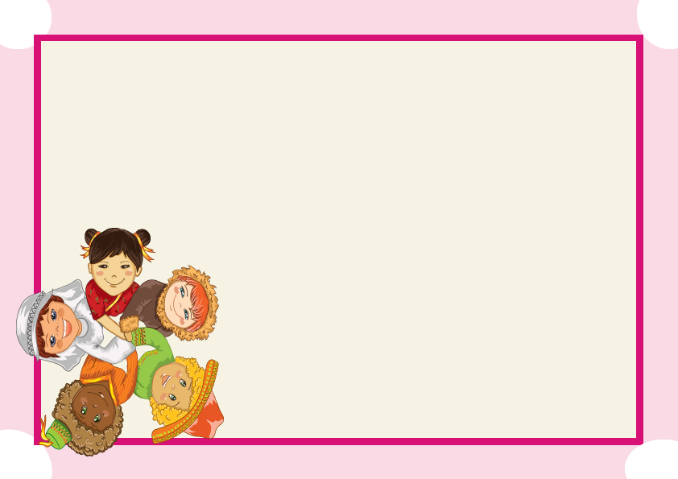

CABBAGE PATCH ADOPTION CERTIFICATE

“Infront of another person raise your right hand and say:
“I promise to love my cabbage patch kids”.______________ With all my heart.
I promise to be a good and kind parent.I will always remember how special
My Cabbage Kids”

This certifies that ______________________________
Who was born in the cabbage patch on

Was adopted by:
And now lives at:

Signature of adopting parent ____________________

Date___________________

Signature of officer _____________________

