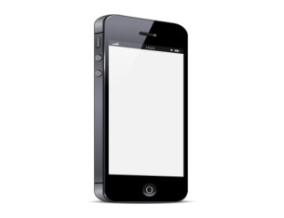 End-User
Service Department
Repair Order Form
Icom (Australis) Ply.Ltd.
ABN 88 006 092 575
Unit 1,103 Garden Road, Chyton, Victoria3168, Austarlia
Phone (03) 9549 7500 Fax (03)9549 7506R
Date: ___________
Owner’sDetails________________________________________________________________________
Given Name (PRINT) Surname (PRINT)
Address: ____________________________________________________________________________
Suburb: ____________________ State: _______________________ Postcode: ____________________
Phone: ____________________ Mobile: ______________________ Fax: _________________________
Email: _______________________________________________________________________________
Radio Details
Model: _______________________________________ Serial Number: __________________________
Accessories included with radio
Antenna Battery Belt Clip Bracket Cable
Instruction Manual Microphone Original Box Other ______
Simple Description about the Fault:
__________________________________________________________________________________
__________________________________________________________________________________
__________________________________________________________________________________
Warranty Repair (A copy of the receipt is required for warranty service)

