­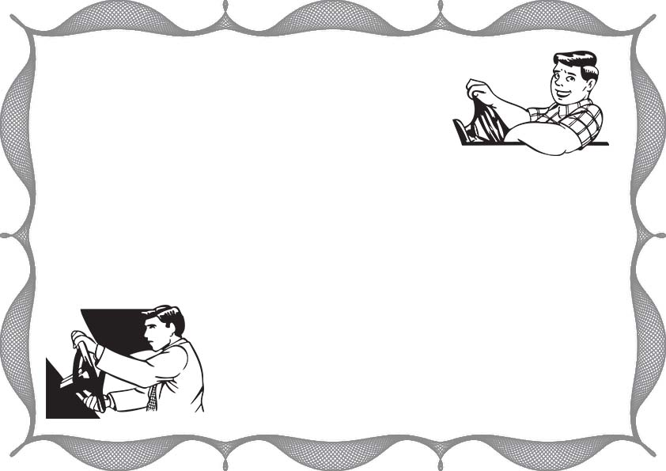

**_____________________________**

**at**

**_____________________________**

**This is Certify Mr/Mrs**

**For Outstanding Contributions to Defensive Driving**

**___________________________**

**Certificate of Defensive Driving**

**Signature:**

**Date:**