­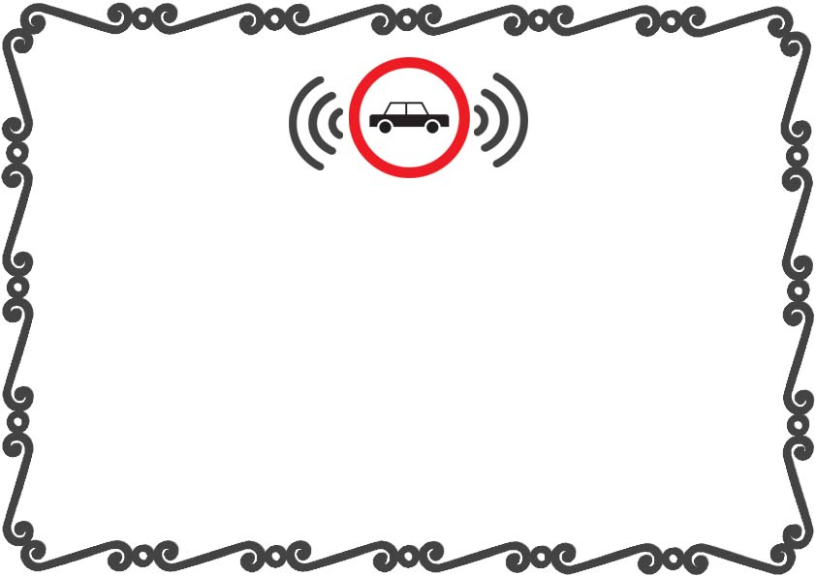

_________________________

___________________________

AT

SIGNATURE:

A STANDARD TO DESTRUCT ONLINE DEFNSIVE DRIVING

_____________________________

THIS CERTIFICATE IS AWARDED TO

Certificate of Defensive Driving

DATE: