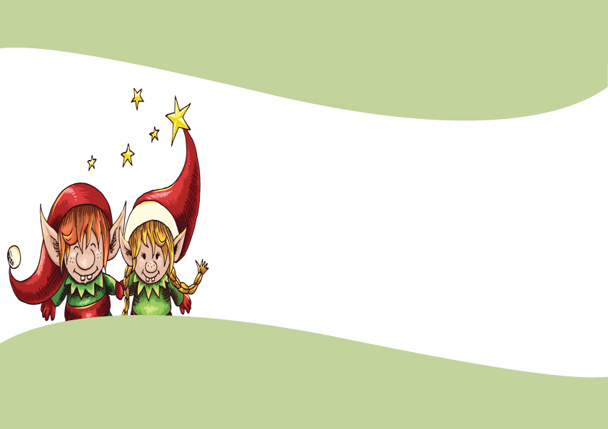
CERTIFICATE OF ADOPTION

This certifies that
_______________________the elf
Has been adopted into the family by:
_________________________________
On__________The__________
Day of ____________,_____________

_________________
Signature

