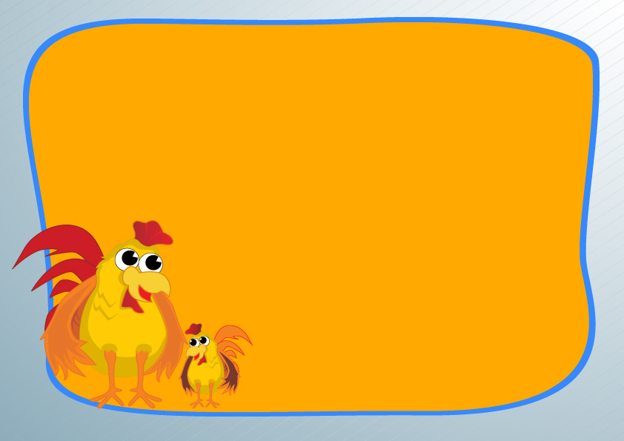

CERTIFICATE OF PET ADOPTION

Name: ______________________________

Type of Pet :_______________________________

Date Of Birth: ______________________________

Adopted:______________________________

Fur Color:______________________________

Belongs To:______________________________

“ My Pet is Special,So cute,I will love it,and care of it..”

