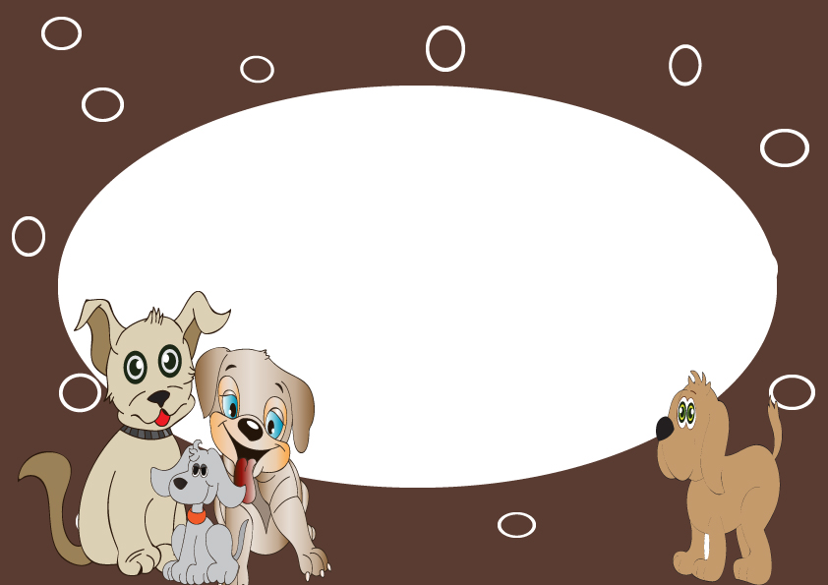

CERTIFICATE OF ADOPTION

This is to certify that ___________________________________

Has officially adopted ________________________________________

By signing this certificate I promise to give my

Puppy a lifetime of love, care, attention, and fun!

I Promise to be their best friend forever.

Signature:_______________

Date:_________________

