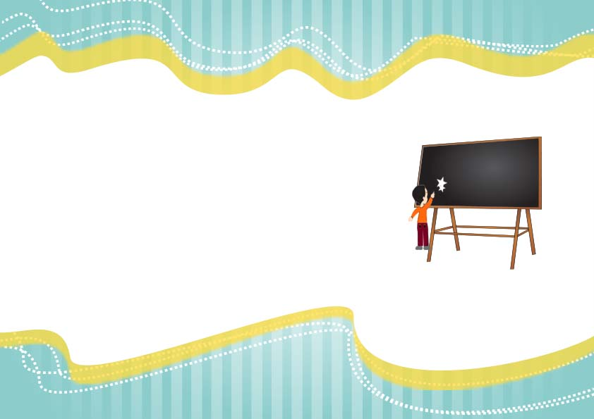

**____________________**

**Teacher Signature**

Awarded to

_____________________

For being the Most Quietest Student in a class room.

Quietest Student Of The Year