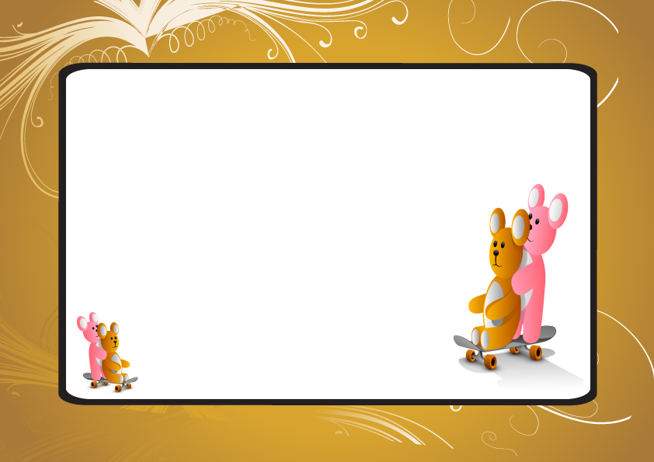

TEDDY ADOPTION CERTIFICATE

This certifies that on ____________________________

A very special teddy bear was born and adopted by:

_________________________________

Name given to bear:______________

Signed:________________

