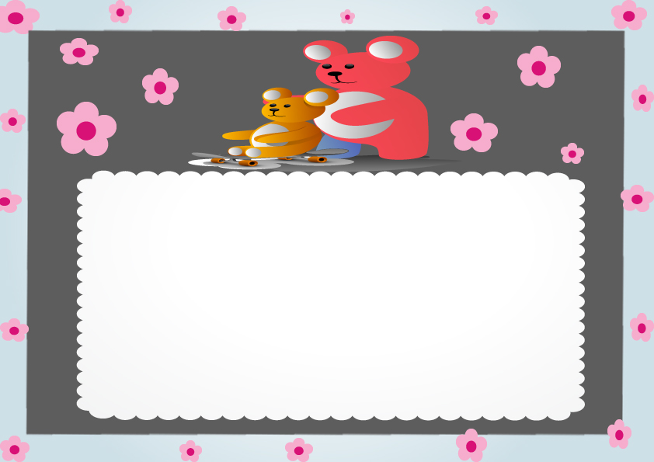

TOY ADOPTION CERTIFICATE

This certifies that on _________________________________

A very special toy was born on adopted by:_________________________

Name given to toy ______________________________________

Signed:______________________________

