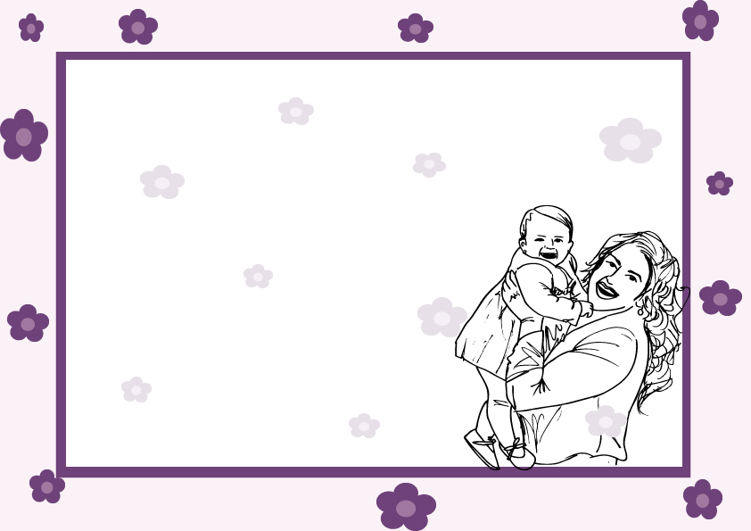

CERTIFIFCATE OF ADOPTION

____________________________________

was adopted on_______________

By ___________

_______________ ________________

