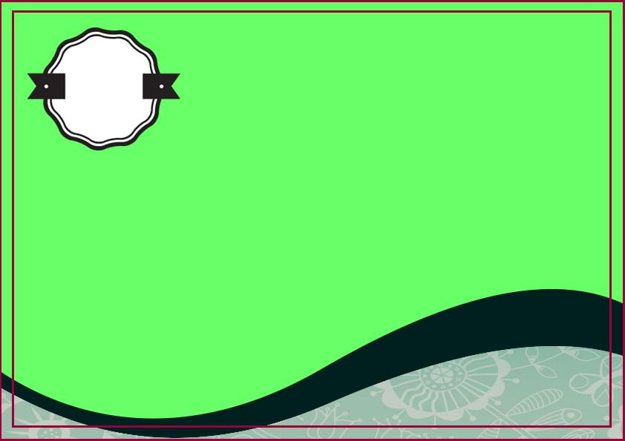

**Certificate of adoption**

**This certificate certify that**

**_____________________**

**Has been officially adopted**

**_______________________**

**On**

**_________**

**Signature**

**__________________**