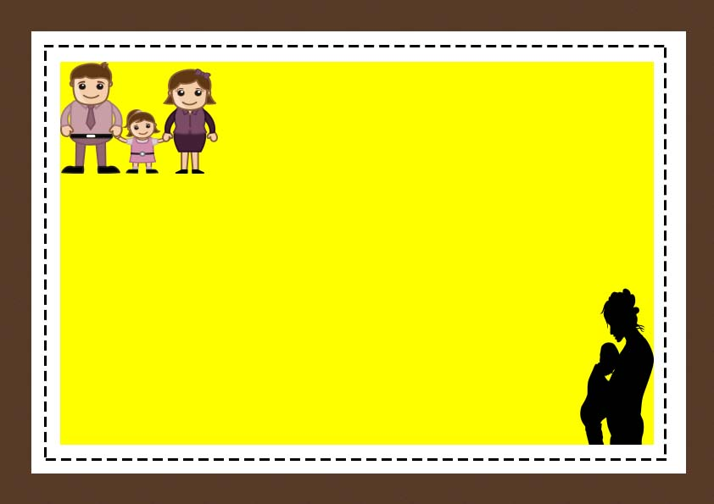

This is to certify that

[Name of Owner]

Has officially adopted

[Name of Child]

On

[Date]

Child Adoption Certificate

**Date**

**__________________**

**Signature**

**_______________**