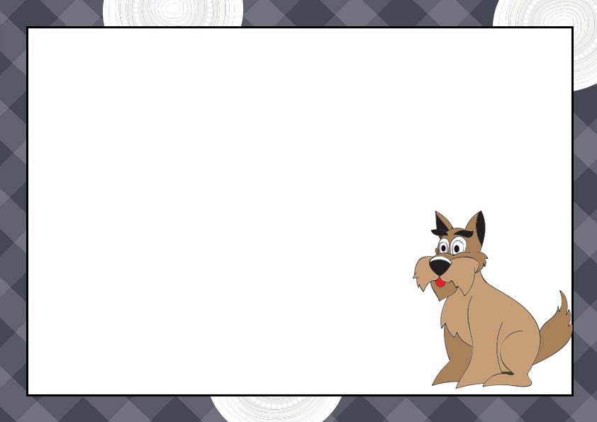

**We love pet and take care of my new pet!!**

Signature

_______________

This certificate certifies that

_________________________

Has adopted

_____________________

Date

_________________

**Certificate of adoption**