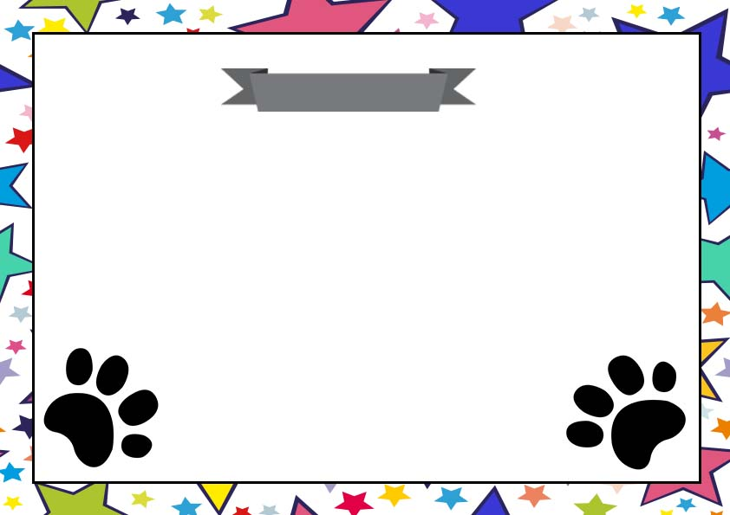

**Pet Name: ________________________**

**Birth date: ________________________**

**Fur and Eye Color: ___________________**

**I Promise to love and take care of my new pet!**

Pet Adoption Certificate

Signature

________________