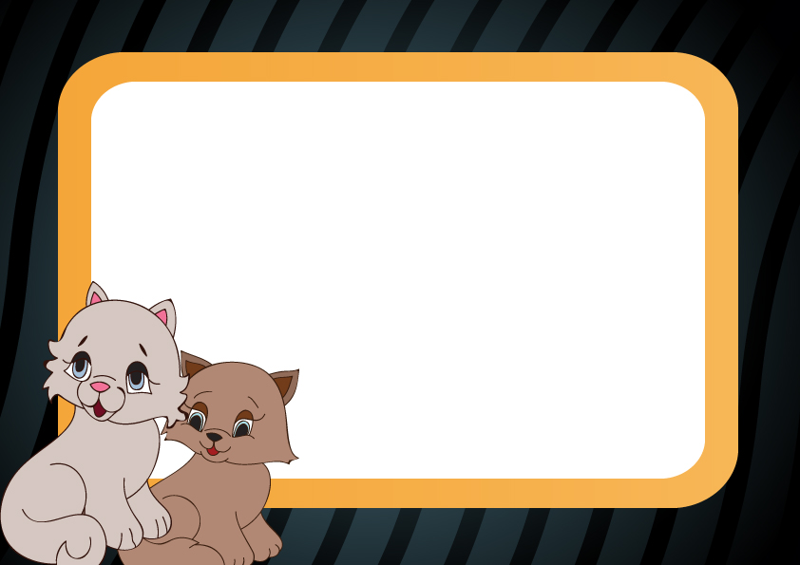

CERTIFICATE OF ADOPTION

This certifies
That
______________________________________________
Became a beloved member of

__________________________________________

__________________________Family

On______________, _________________

In________________,______________

At _______________________________

