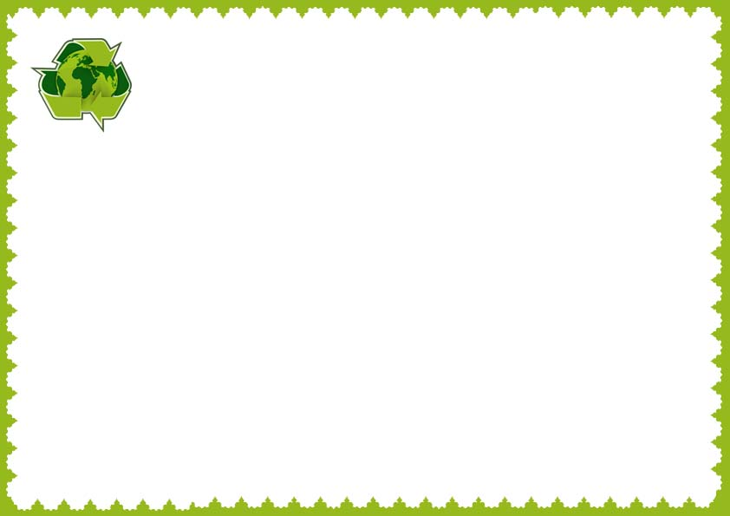

This certificate is presented to

_______________________

I certified that all methods of destruction are in compliance with

Internationally recognized standards

Company name ____________ issued by _________________

______________ _____________

Certified by Date

**Destruction Certificate**

**______________ _____________**

**Signature Date**