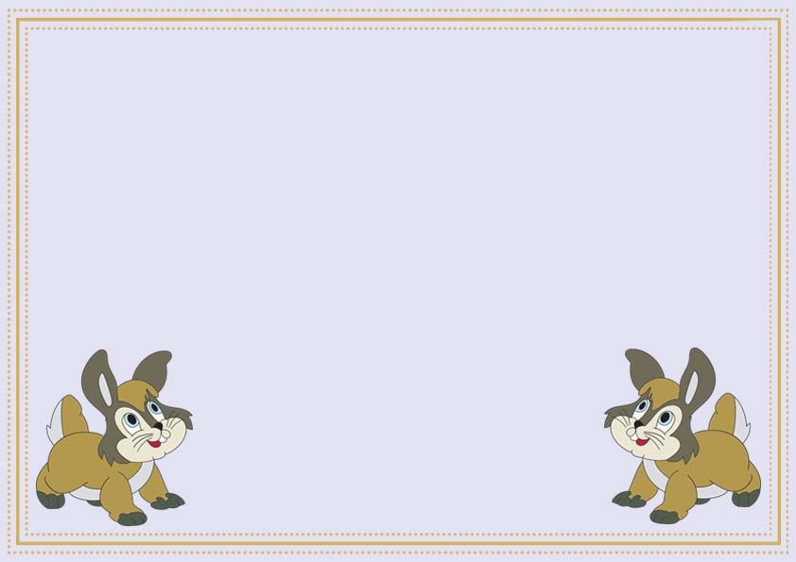

**Certificate of Adoption**

This is to certify that

_______________________

Has officially adopted by

_______________________________

And he/she will live a happy healthy fun life him/her in his/her forever home!!!

______________ _____________

Signature Date