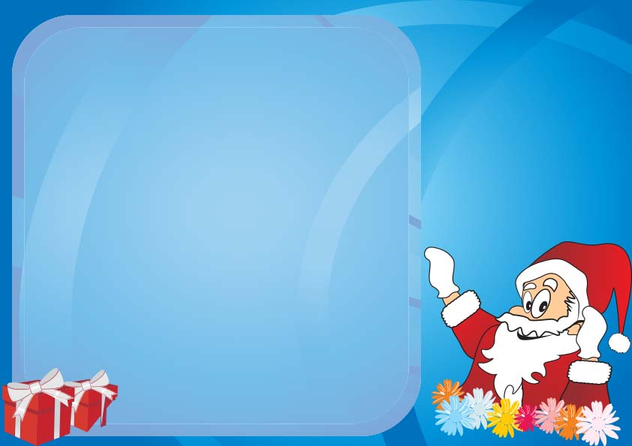

*Santa’s SEAL HERE*

YOU ARE CURRENTLY ON THE NICE LIST

THIS LIST WILL BE CHECKED TWICE

Sharing Toys

Being Helpful

Picking up toys

Listening

As Reported by your ELF:

*NAME HERE*

Reasons for being on the list,

|  |
| --- |
|  |

|  |
| --- |
|  |

|  |
| --- |
|  |

|  |
| --- |
|  |

**OFFICIAL NOTICE**