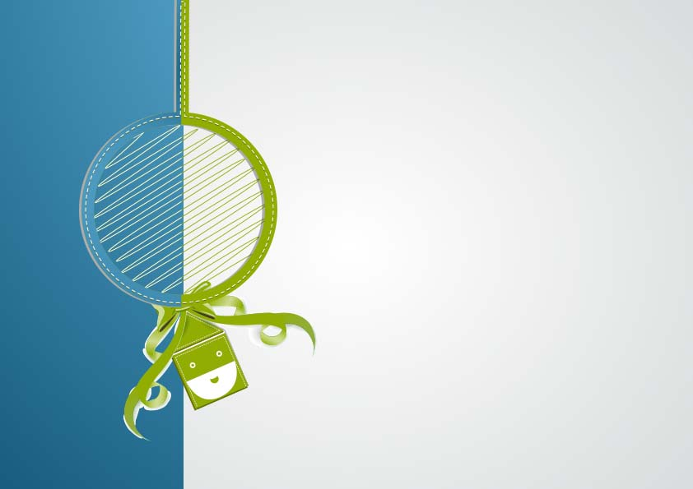

**Official Signature: ____________________________**

For demonstrating good behavior and keeping the Christmas spirit all year long,

_________________________________

Is hereby placed on

Santa’s official Nice list for **\*Year\***

**Nice List Certificate**