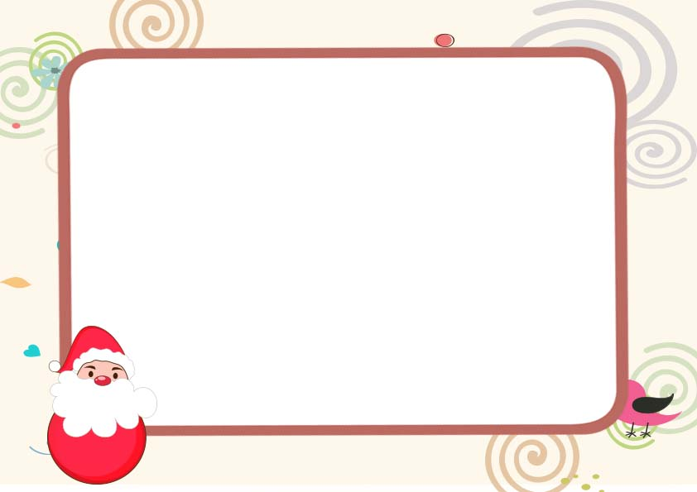

_____________________ _______________________

SANTA CLAUS Head ELF

In recognition of your good behavior

This year I, Santa Claus, hereby place

______________________

On **This year’s Santa Nice List**, Check twice.

Santa’s official Nice List

CERTIFICATE