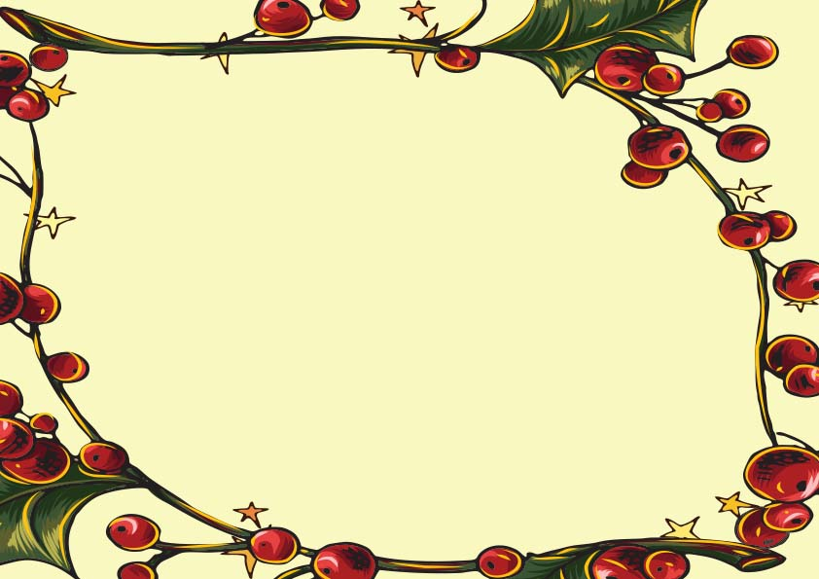

**_________________________  
SANTA CLAUS**

IN LIGHT OF YOUR MISCHIEVOUS AND NAUGHTY DEEDS THIS YEAR,

I, SANTA CLAUS, OFFICIALLY PLACE

____________________________________

ON THE # NAUGHTY LIST THIS CHRISTMAS

**-Santa’s Official-**

Naughty List Certificate