­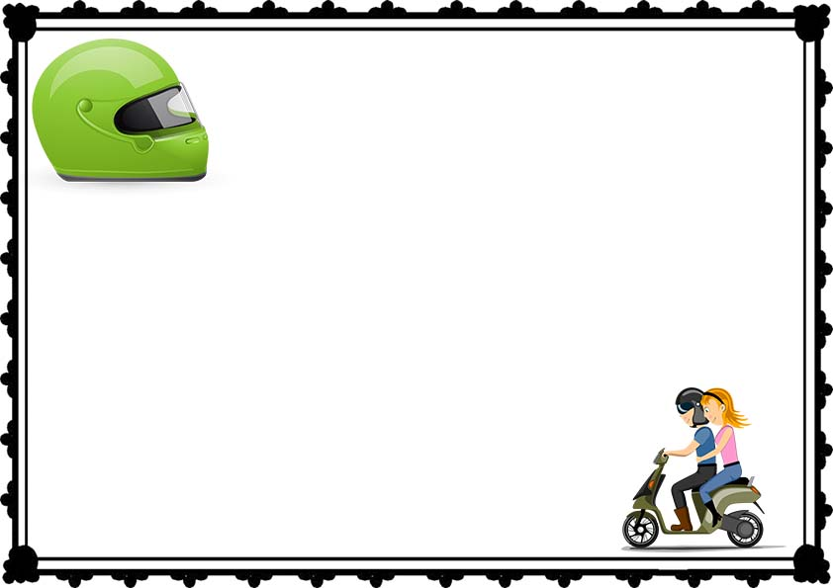

This is Certify Mr/Mrs

**_____________________________**

**___________________________**

**_______________________**

at

A Standard Certificate to Instruct Safe 2 Drive

Date:

Signature:

**CERTIFICATE OF SAFE 2 DRIVE**