­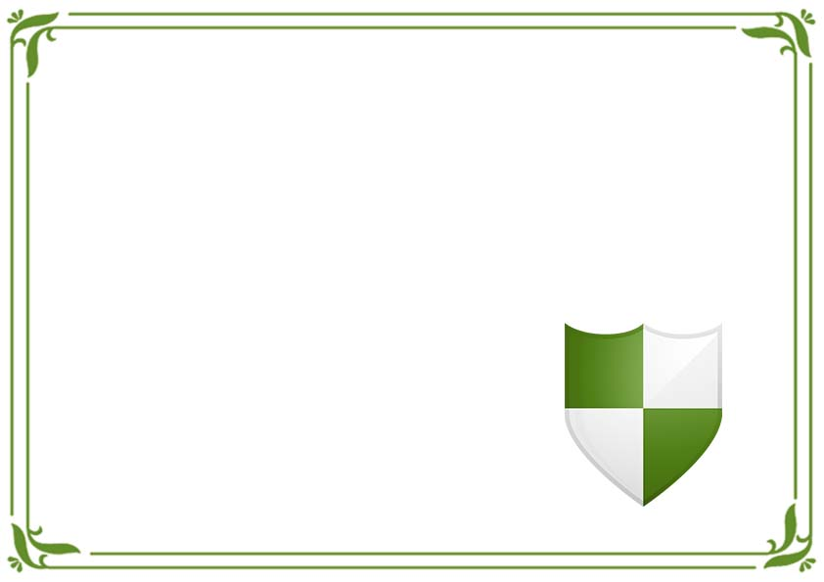

This is Certify Mr/Mrs

**_____________________________**

A Standard Certificate to Instruct Safe 2 Drive

**___________________________**

Issued By

Date:

Signature:

**Certificate of Safe 2 Drive**