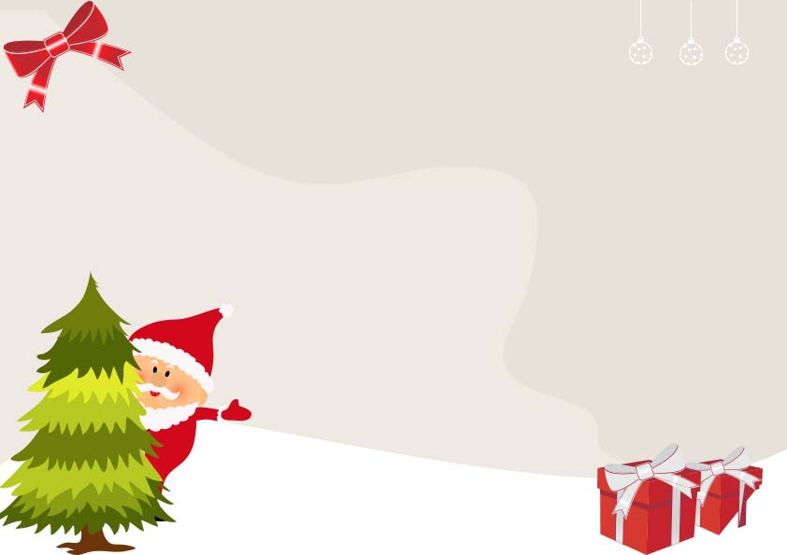

Signed: ________________________

Date: _________________________

**Name: ____________________________**

**Is enrolled on the official Santa Claus Nice list in recognition of nice manners and good behavior during the past year.**

**Santa Claus Nice List**