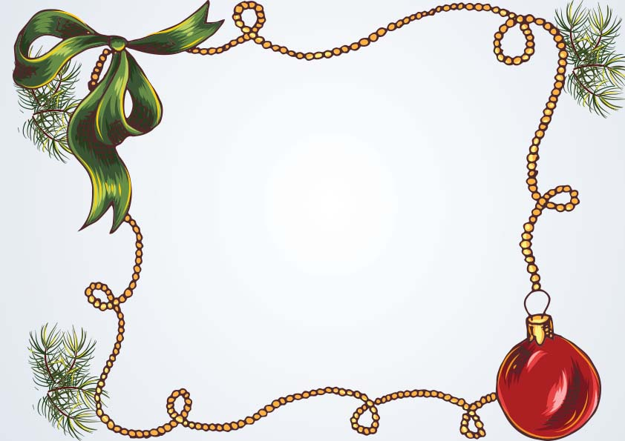

Signature: ___________________

As a reminder of your naughty behavior and for messing up all year round.

I, Santa Claus, hereby place

___________________________

On this year’s naughty list

Naughty List

**Certificate**