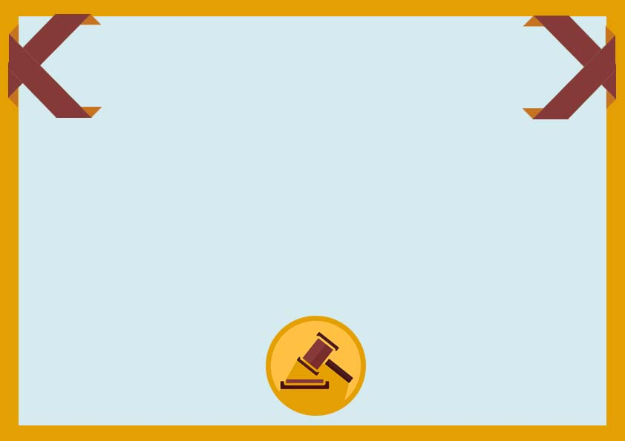

**Auction Certificate**

**______________ _____________**

**Signature Date**

**This certify to that**

**_______________________**

**For his/her outstanding participation in silent auction**

**Auctioneer ____________ Place _________________**

**______________ _____________**

**Signature Date**