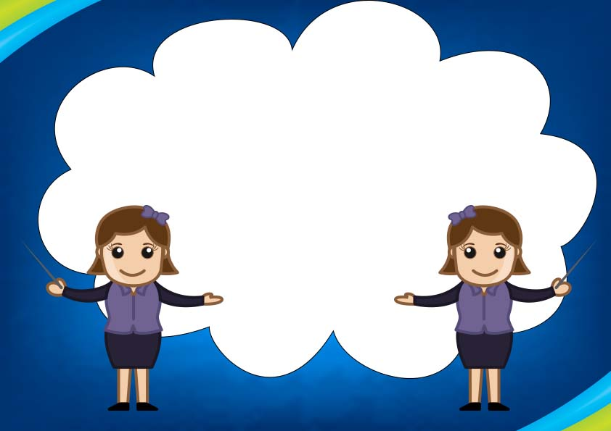

**Sincerest Thanks,**

**______________________________**

**A very special thank you to**

**_____________________________________**

**For helping to open up**

**The world of learning.**

Special Teacher