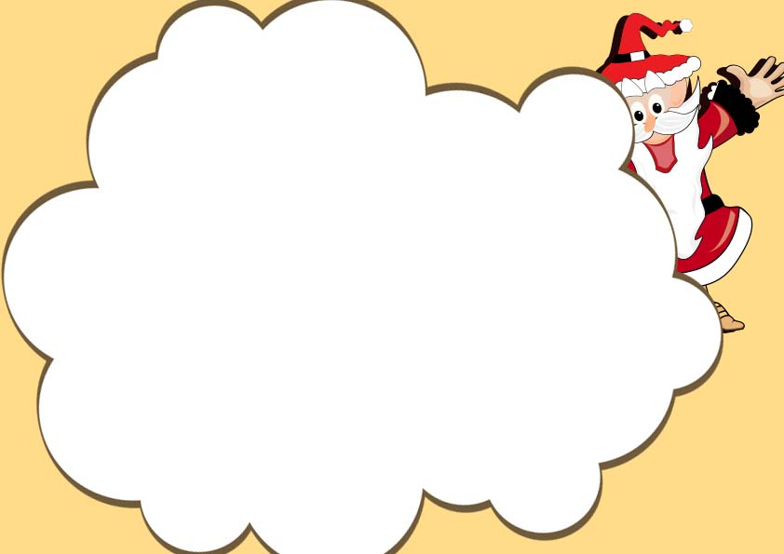

In recognition of your good behavior

This year I, Santa Claus, hereby place

________________________

On This year’s Santa Nice List,

Checked twice

Santa’s Official Nice List

Certificate

________________________

Santa Claus, Year