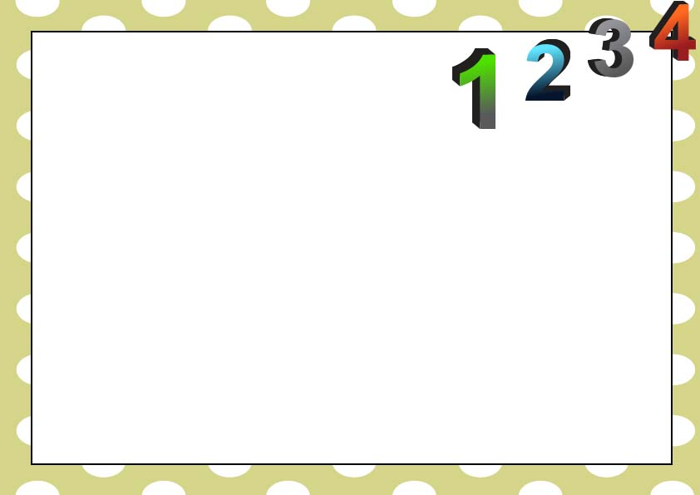

______________________

Teacher

This certificate is presented to

__________________________

For Reading Counts

From ______ to ________

You Did It!

Best Count Reader