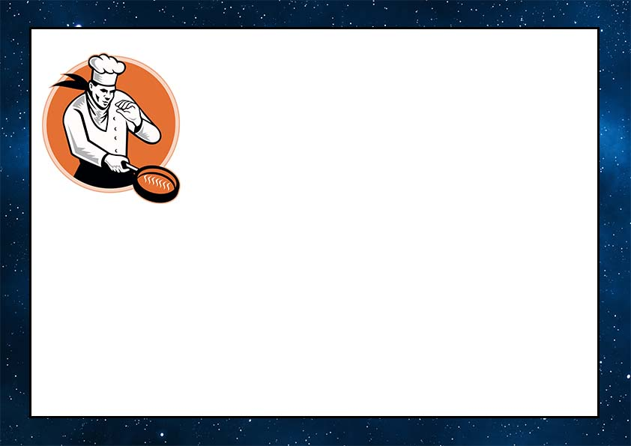

**Fork & Dine**

**This Certificate is presented to   
Mr. /Ms. ________________________**

**For doing good job in Cooking Course at**

**Fork & Dine Cooking School**

**On *Date\***

Signed By: __________________________

**Courses For Cooks**