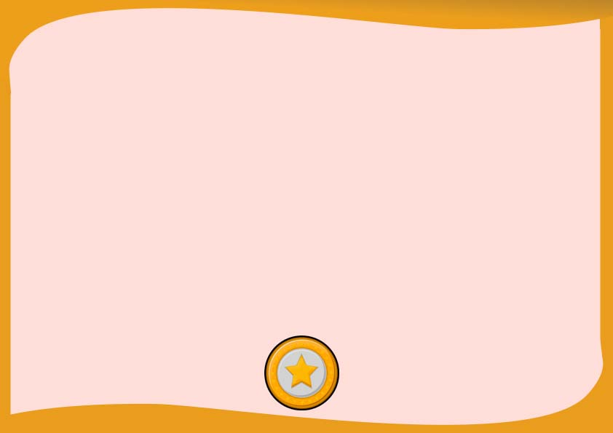

This is presented to

_______________________

For completing the Cub Scout leader of recognition and valuable performance

Chairperson ________________ Committee ______________

______________ ____________

Signature Date

**CERTIFICATION OF CUB SCOUT**

**______________ _____________**

**Signature Date**