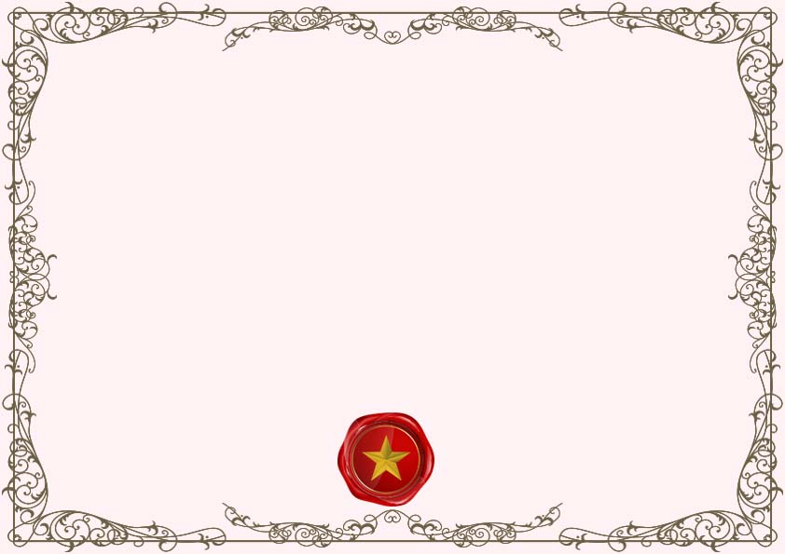

**Marriage Counselling Certificate of Completion**

**______________ _____________**

**Signature Date**

This certifies that

_______________________

Were united in the holy bonds of matrimony

Place ____________ on _________________

______________ _____________

Signature Date