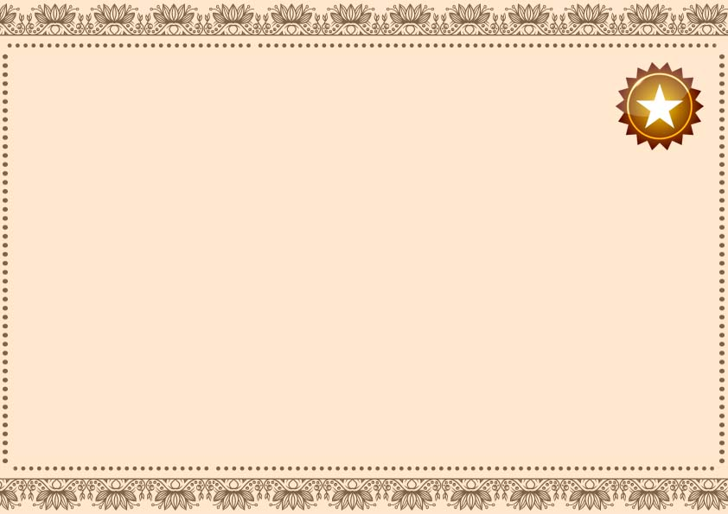

**Certificate of Land Compliance**

**______________ _____________**

**Signature Date**

**This certificate dated the**

**_______________________**

**Under the seal of the district land registrar**

**Owner name __________________ place __________________**

**______________ _____________**

**Signature Date**