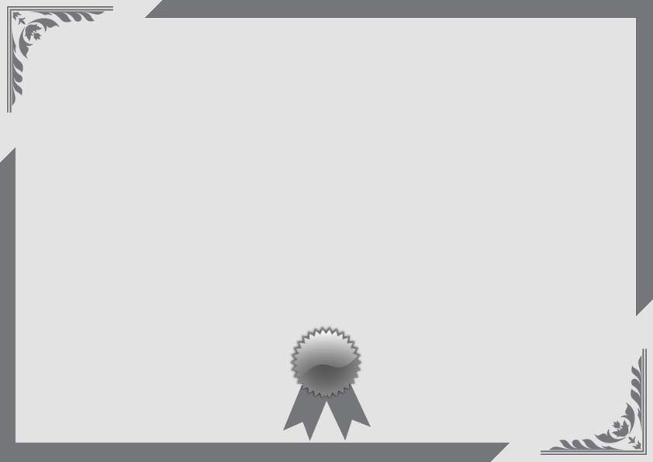

We proudly present this certificate

_______________________

For her achievement of best hair awarded on

The Master of Science in speech language pathology

Place ____________ at _________________

______________ _____________

Signature Date

**SUPERLATIVE CERTIFICATE**

**______________ _____________**

**Signature Date**