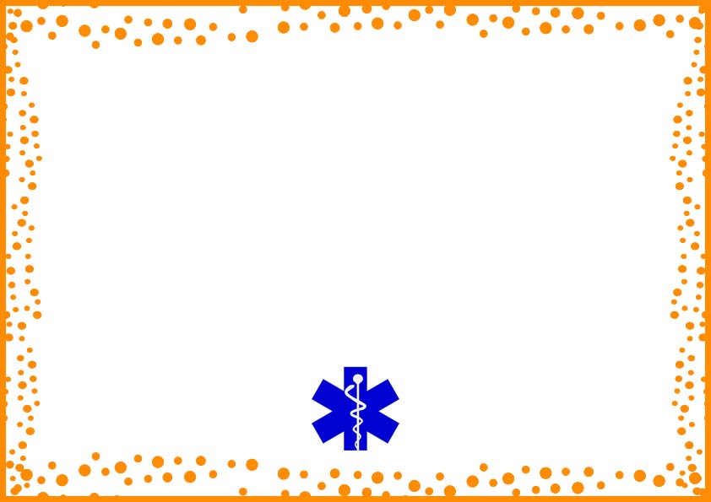

This is to certify that

________________________________

Has demonstrated that it has the necessary organisational capability

In relation to skill & knowledge to carry out the animals with care

Authority name ________________ Disclosure ______________

______________ _____________

Signature Date

**CERTIFICATE OF**

**HEALTH & SAFETY ACCREDIATION**